Weed Pulling Party Work List
Tomorrow is our “spruce up” event here at the church. You will see the work list below. We will be meeting out front by the sanctuary main doors at 8:00 a.m. to get organized and have a prayer. We plan to work 8 – 12 and then will enjoy a nice meal by our Deaconess team at noon. See ya there.

Inner Court Garden – Table Repair -
Jeri Lynn Team Leader Lynden Kruse Team Leader
- Bush trimming - Replacing wood on picnic
- Weed pulling tables
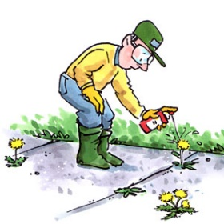
- De-heading dead flowers

Weed Eating – Dennis Mason Team Leader
- Behind BLC (storage bldgs & to property line)
- Back side of prkng lot dwn to property line
- Parking lock cracks
- Evergreen grove (between church and Fred’s)
- Along road (between church and Fred’s)
- Edging of all grass areas (behind church)

Weed Pulling – Melony Coleman Team Leader
- All rock beds/mulched beds weeded - De-heading dead flowers
- Raking wood chips over the sprinkler lines that are exposed

