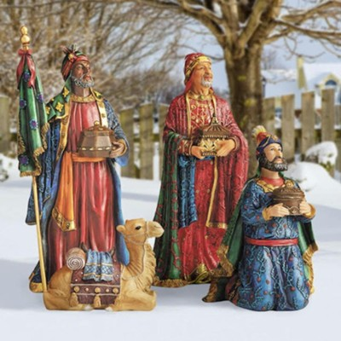

Those who give are those who live
But how to be supportive ?
Three great thoughts for your contemplation
The following still need completion
Without each other these are massive
But giving together will make them active
Thank you for considering the following in your local year-end giving:
…..New Front Entry
…..New Church Digital Sign
…..Pathfinders - International Camporee

Those who give are those who live
But how to be supportive ?
Three great thoughts for your contemplation
The following still need completion
Without each other these are massive
But giving together will make them active
Thank you for considering the following in your local year-end giving:
…..New Front Entry
…..New Church Digital Sign
…..Pathfinders - International Camporee

