Photo Directories
The photo directories are going to print next week. The company is selling photo directories to anyone who would like more than one, or would like to purchase one due to not being able to get your picture in the directory. They are 20 dollars a directory. (If you had your picture taken or you submitted a selfie, you will receive one free directory.)
Please indicate below your desire:
- I would like _____ directory/directories for $20.00 apiece.
Name: __________________________________________________
Please put in the offering plate or give to a deacon following the service.

40 Days of Prayer
Starting January 1st

Jesus invited, in preparation for His Second Coming to watch, work and pray for the salvation of our friends, family and neighbors. The Roseburg Church is launching into a year of events aimed at sharing Good Tidings to our friends, families and neighbors through various different types of evangelistic events. We would like to launch this year off with a prayer emphasis and are excited to announce that starting January 1st, we will be hosting a 40 Days of Prayer initiative. Our desire would be that every family participate in this event.
We will have a book that will guide our daily prayer and devotions called, “40 Days of Prayer, Prayers and Devotions to Prepare for the Second Coming”. The church will provide one book per family. In an effort to have enough books, please take time to fill out the below information.
- Yes, I would love to participate. Please reserve one of these books for my family.
Name: _______________________________________________________
Please put in the offering plate or give to a deacon following the service.
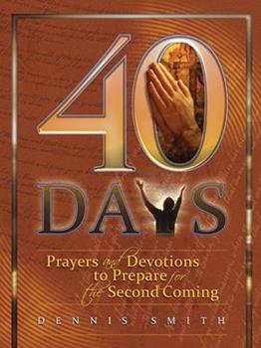

If you would like more than one book, they can be purchased at the ABC

